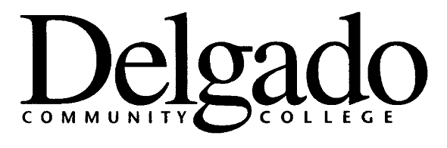
ELECTRONIC MESSAGE BOARD

______________________ CAMPUS

To request that your message appear on the appropriate campus sign, please fill out the information below and email to cjones@dcc.edu. Thank you.

START DATE_______________20 ______ END DATE___________________ 20______

# | Frame…..

Please limit to 12 characters per line including spaces, etc. Please be brief and to the point. Each frame can take up to two lines of information.

1

2

3

4

5

Date Submitted:____________________
(Edit accordingly)

Cynthia B. Jones
DELGADO COMMUNITY COLLEGE / CITY PARK CAMPUS
615 CITY PARK Avenue, New Orleans, LA 70119-4399

 OFFICE OF INSTITUTIONAL ADVANCEMENT
(504) 671-5412  Fax: (504) 671-5492

