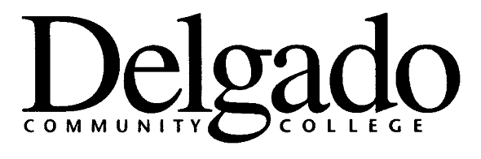
DIRECT DEPOSIT ENROLLMENT AUTHORIZATION

EMPLOYEE SSN | DEPARTMENT/OFFICE
ACTION TYPE (√ one)
____NEW ___ CHANGE ___ TERMINATE THIS OPTION

ACCOUNT INFORMATION

FINANCIAL INSTITUTION NAME | FINANCIAL INSTITUTION ROUTING (ABA) NUMBER (Bank Key)
BANK ACCOUNT NUMBER | ACCOUNT NAME (Ex: Mr. & Mrs. John Doe, John or Jane Doe, John Doe)
___ *CHECKING (*Provide voided check or account verification)

PERCENT OF NET TO THIS ACCOUNT _______________________ OR FIXED DOLLAR AMOUNT TO THIS ACCOUNT ____________________

FINANCIAL INSTITUTION NAME | FINANCIAL INSTITUTION ROUTING (ABA) NUMBER (Bank Key)
BANK ACCOUNT NUMBER | ACCOUNT NAME (Ex: Mr. & Mrs. John Doe, John or Jane Doe, John Doe)
____ *SAVINGS (*Provide voided deposit slip or account verification)

PERCENT OF NET TO THIS ACCOUNT _______________________ OR FIXED DOLLAR AMOUNT TO THIS ACCOUNT ____________________

(Print full name)

I ________________________________________________ authorize and request Delgado Community College to direct my net pay check to the account at the financial institution I designated above.

For any funds paid to me which are not due and owing to me, I hereby agree and authorize my appointing authority (employer) to adjust the amount next due to me to correct the overpayment, or to recover amount overpaid by reducing my future payroll checks so that the overpayment will be repaid or recouped within a reasonable number of months [not to exceed 12 months].

It is my responsibility to notify my employer, as appropriate, should any changes occur to account specified. Considering all above conditions are met, this authorization remains in full effect until a written signed notification to terminate, or another signed form indicating termination of this option is received from me and Delgado Community College has had reasonable opportunity to act on the termination. However, I understand and acknowledge that I am responsible for any account information that I add or any changes that I make to my accounts.

_____________________________________ ______________________ ________________________________
Signature Date Phone where you can be reached
between 8:00 and 4:30

(6/05)

