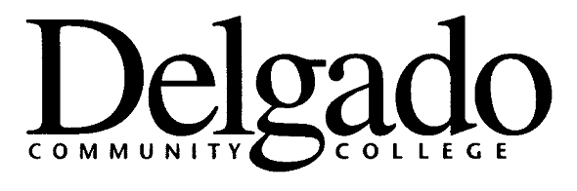
PURCHASING CARD PROGRAM

CARDHOLDER AGREEMENT

I AGREE TO THE FOLLOWING TERMS AND CONDITIONS REGARDING THE USE OF THE DELBADO PURCHASING CARD ASSIGNED TO ME FOR OFFICIAL STATE BUSINESS ONLY.

1) I understand that I am being entrusted with a powerful and valuable tool and will be making financial commitments on behalf of Delgado Community College and the State of Louisiana and will strive to obtain the best value for the College and State.

2) I understand that under no circumstances will I use the Purchasing Card to make personal purchases, either for myself or others. Using the Purchasing Card for personal gain or unauthorized use may result in disciplinary actions up to and including termination of employment and prosecution to the extent permitted by law.

3) I understand that the card shall be solely used by me, the named cardholder, and that under no circumstances shall any other person be allowed to use this card.

4) I will follow Louisiana Law, State purchasing policies, and the policies and procedures of Delgado Community College, and the established guidelines for using the Purchasing Card. Failure to do so may result in either revocation of my card privileges or other disciplinary action.

5) I have been provided a copy of the State and College Purchasing Card Policies, Procedures, and Guidelines. I attended training on __________________________ (date) and I understand the Purchasing Card Program. I have been given an opportunity to ask any questions to clarify my understanding of the Purchasing Card Program.

6) I agree to review and reconcile transactions timely and will maintain all applicable information and receipts.

7) I agree that I will surrender the purchasing card upon termination from Delgado Community College.

8) If card is lost or stolen, I understand I must call Bank of America Customer Service at 1-888-449-2273 immediately. This number is available 24 hours a day, 7 days a week, 365 days a year. I understand that lost cards reported by phone are blocked immediately and replacement cards are issued within 24 hours.

9) I agree that, should I violate the terms of the Agreement, I will be subject to disciplinary action up to and including termination of employment and that I will reimburse the State of Louisiana for all incurred charges and any costs related to the collection of such charges. Additionally, any such charges that I owe the State may be deducted from any money which would otherwise be due and owing me, including salary or wages, to the extent allowable by law.

______________________________________

Cardholder Name (print)

______________________________________ Date: ________________________

Cardholder Signature

Received by Delgado Purchasing Card Administrator: ____________________________ (signature and date)

Form 3300/011 (12/09)

