PUBLIC RELATIONS AND MARKETING
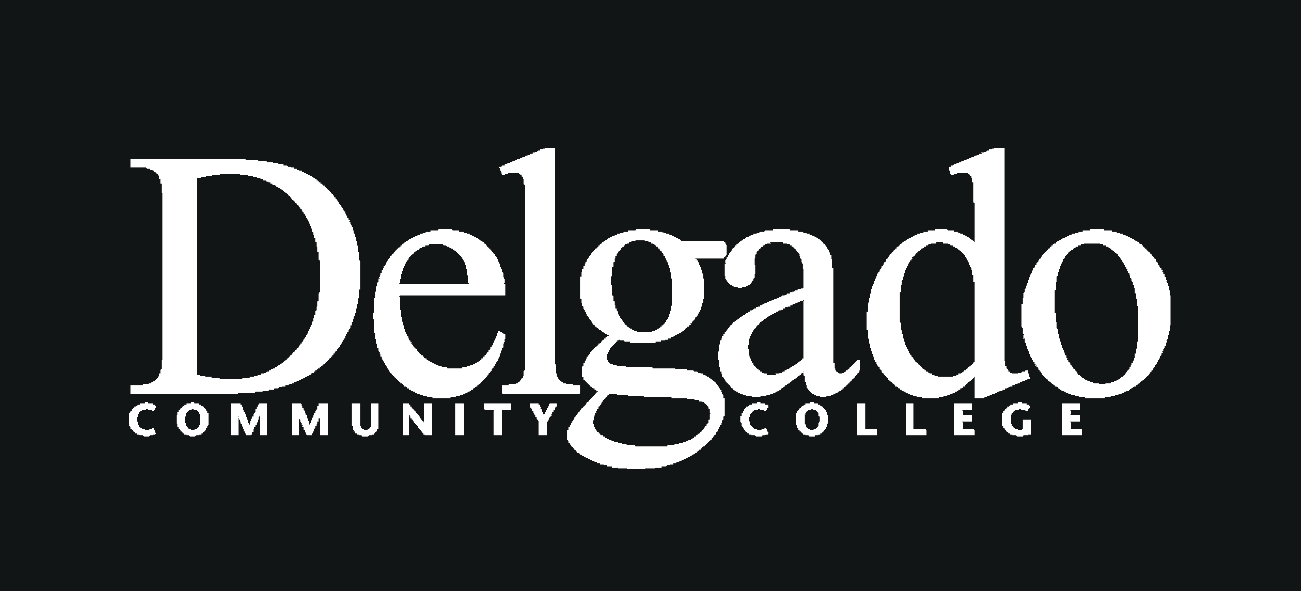
DESIGN/PRINT WORK ORDER

Fiscal year __________________ Item name ____________________________

PUBLIC RELATIONS AND MARKETING USE

Work order received _________
Job number _________
First proof sent _________
Final revisions received _________
Approved _________
Completed _________
Printer ___________________________
Total cost $ _______ Unit cost $_______
Paid for by ________________________

P-card or Req/PO# ______________
REQUIRED INFORMATION

Date work order submitted:

Preferred completion deadline:

Contact person:

Phone:
E-mail address for proof:

Department:

Department account number:

Departmental approval signature:

This form must accompany each request for printed or electronic materials produced by Delgado’s Public Relations and Marketing team. Signature of department head requesting items is required and assumes responsibility for any copy sent and certifies that signer is totally responsible for all contents of reproduced material. Please submit ONLY ONE form per item to the publications coordinator via campus mail,
e-mail (lsalin@dcc.edu), or fax (504) 483-4288. All work, with occasional exceptions, is managed on a first-come, first-served basis.

CONTENT

Images: Text:

Select from PR photo gallery
Supplied electronically*
*Must be 300 dpi/1MB JPG or EPS
Photo shoot needed
Use stock image(s) of

Supplied electronically
Hard copy attached
Need copywriting

ITEM SPECIFICATIONS

Item name/type:

Quantity: ___
Artwork to print at Xerox Duplicator
Artwork to print at outside vendor
Artwork only
File format:

Ink:
black only
1-color
2-color &
4-color
Printing: 1-side 2-sides
Paper stock color:

Paper stock type:
bond/copy
110# cardstock - glossy matte
glossy poster stock
NCR 2-part (white/yellow)
NCR 3-part (white/yellow/pink)
NCR 4-part (white/yellow/pink/gold)
other ______

Other instructions: ______________________________________________________________________________________________________

Mailing:
Print addresses on pieces
Excel mailing list supplied
Need assistance with printing labels
Postage type:
Non-profit indicia Metered mail
First-class indicia Affixed by Delgado mailroom
Indicia/Permit #:

Item dimensions:
Flat size: _______________________
Finished Size:
letter 8.5x11” legal 8.5x14”
½ letter 8.5x5.5” ¼ letter 4.25x5.5”
postcard for USPS mailing 6x4.25” (Delgado logo and
return address ONLY are permitted on back side of card;
must be printed on 110# cardstock)
giveaway card - 3.5x5” 6x4.25” 5x7”
brochure - 6-panel 9x12” 8-panel 9x16”
A2 invitation card 5.5x4.25”
A2 folded invitation card 5.5x8.5”
A2 invitation envelope 5.75x4.375”
other
USPS funding – Check request to Postmaster: $

Posters:
Orientation - portrait landscape
Poster only
11x17” - 9¢ each at Xerox Duplicator
15x20” - $1.84 each*
20x30” - $3.75 each*
30x40” - $4.50 each*
Poster with foam board mounting
15x20” - $3.84 each*
20x30” - $7.50 each*
30x40” - $9.10 each*
* Printed on Public Relations poster printer

Updated 8/2011

