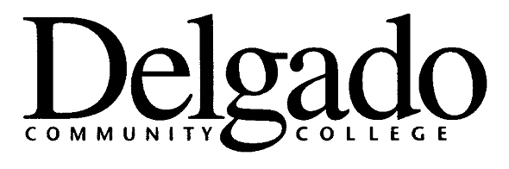
ELECTRONIC MESSAGE BOARD
CITY PARK CAMPUS
To request that your message appear on the City Park Campus sign, please fill out the information below and email to mcourt@dcc.edu. Thank you.

ACTION: START DATE__________
END DATE_____________

# | Frame…..

Please limit to 12 characters per line including spaces, etc. Please be brief and to the point. Each frame can take up to two lines of information.

1

2

3

4

5

Date Submitted:_______________
Edit accordingly

SHELINDA P. HARRIS
Administrative Assistant / Building 37
DELGADO COMMUNITY COLLEGE / CITY PARK CAMPUS
615 CITY PARK Avenue, New Orleans, LA 70119

 OFFICE OF PUBLIC RELATIONS & MARKETING (504) 671-5497
 DIRECT: (504) 671-5491  Fax: (504) 671-5492
E-MAIL: sharri@dcc.edu

