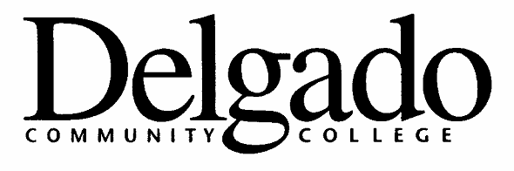
Mobile Communications Device Acceptance Agreement Form
Name: Date:

Job Title: Department:
Description of Mobile Phone
Mobile Device: Number Assigned:

Serial #:

Justification:

I certify that:

- I have read and agree to the Delgado Mobile/Electronic Messaging Device Policy (BAA-E01);
- I understand that I must complete this acceptance agreement form, with prior signature approvals, prior to accepting a Delgado-issued mobile or electronic messaging device;
- I am responsible for proper use and acceptance of the terms associated with the particular device;
- Use the equipment for job-related purposes (personal use should be limited);
- I must return the equipment to the Office of Information Technology upon demand, and notify the Office of Information Technology immediately upon damage or loss of the device.
- I am responsible for the cost incurred for replacing the unit in the event the damage or loss is my fault;
- I must properly use the equipment in regards to voice communication and data etiquette during transmission and reception of messages, and adhere to the requirements of the College’s Information Technology Security policy while using the personal mobile or electronic messaging device when performing official business;
- Adhere to the particular rate plan chosen by the College, as deemed appropriate to the user’s job function.

I have received the aforementioned device and will adhere to requirements above.
___________________________________ _________________
Employee's Signature Date

Approvals:

___________________________________ _________________
Supervisor’s Signature Date
__________________________________________ __________________
Assistant Vice Chancellor/Chief Information Officer Date
Officer
For IT Office Use:

Copies: Employee, Supervisor; Original: Information Technology Office
Form BAA-E01/002 (8/12)

