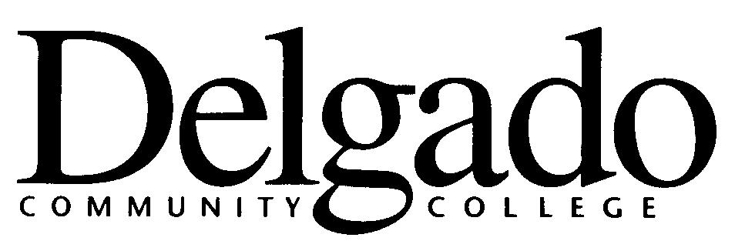
Articulation Agreement Review
Agreement Title: ____________________________________________________________

Approval Date: _______________________ Anniversary Date: ____________________

Recommended Action: Renew/Maintain Agreement (no changes required)

Recommended Action: Modify Agreement and Renew (minor changes required)

Curriculum Revision (Delgado) _____

Curriculum Revision (Senior College Partner) ______

Other (please describe): ________________________________________________ ____________________________________________________________________
____________________________________________________________________

Recommended Action: Terminate Agreement

Program Terminated, Phased out, or Significantly Revised (Delgado/Partner) ____

Student Progress Not Acceptable (result of assessment/feedback) ____

Student Interest Lacking (data supported: attitudinal/quantitative) ____

I have reviewed the referenced agreement, approve the recommended action(s), and certify the agreement is aligned with the College’s mission and program’s purpose.

___________________________________ __________________________ _________
Dean’s Name (print) Dean’s Signature Date
Division (print) ____________________________________________________________
- - - - - - - - - - - - - - - - - - - - - - - - - - - - - - - - - - - - - - - - - - - - - - - - - - - - - - - - - - - - - - - - - - - - - - - - - - -
Received: Office of Curriculum, Assessment, and Program Development _______________

________________________________________
Executive Director, Curriculum, Assessment, and
Program Development
Form 1438/001 (11/12)

