Policy No. AA-1625.1D
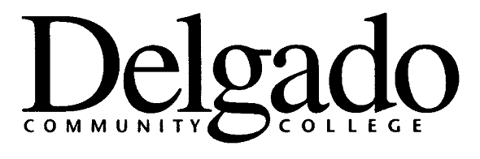

POLICY & PROCEDURES MEMORANDUM

TITLE: CHARTER:
COMMITTEE ON
ACADEMIC &
ADMISSION STANDARDS

EFFECTIVE DATE: February 1, 2005

CANCELLATION: AA-1625.1C (12/19/00)
OFFICE: Academic Affairs (AA)

CHARTER
FUNCTION

The Committee on Academic and Admission Standards will:

1. Review and make recommendations for the academic standards and admission requirements of the College;

2. Review and make recommendations concerning the admission requirements of the selective admission programs of the College, including consistency and fairness in the various selection procedures and criteria;

3. Evaluate and recommend probation and suspension policies for the College; and

4. Recommend and monitor general graduation requirements for certificates and degrees.

MEMBERSHIP

The Committee on Academic and Admission Standards will be appointed by the Chancellor of Delgado Community College and will be composed of representatives of each campus. Ex officio members include: the Vice Chancellor for Learning and Student Development, City Park Campus Provost, West Bank Campus Provost, Provost of the Charity School of Nursing Campus, Dean of Delgado Northshore, all Deans of Student Affairs, and the Director of Institutional Effectiveness. The College Director of Admissions and Enrollment Services and the College Registrar will serve as the administrative support for the Committee.

TERMS OF OFFICE

Each member of the Committee will serve for staggered three-year terms. The Chair will be appointed by the Vice Chancellor for Learning and Student Development.

MEETINGS

The Vice Chancellor for Learning and Student Development directs the Committee Chair to call the initial meeting within one month of appointment of the new Committee. Subsequent meetings are called by the Chair as required to accomplish the responsibilities of the Committee.

REPORTS

The Chair of the Committee will prepare and submit the required reports to the Vice Chancellor for Learning and Student Development as published in the yearly Operational Guidelines documenting the progress of the committee, with copies to the committee members.

CANCELLATION

This policy and procedures memorandum cancels AA-1625.1C, Charter: Committee on Academic & Admission Standards, dated December 19, 2000.

SIGNATURE

Alex Johnson
Chancellor

Attachments:
Committee Standard Forms:

Committee Initial Report (Form A)

Committee Recommendation Form (Form B)

Committee Attendance Report (Form C)

Committee Final Report (Form D)

Policy Reference:
Delgado Policy and Procedures Memorandum, Academic Status
Principles of Accreditation, Southern Association of Colleges and Schools, Commission
on Colleges

Review Process:
Academic Affairs Council 12/2/04
College Council 2/1/05

Distribution:
Distributed to Faculty and Staff Electronically Via Intranet and E-Mail

