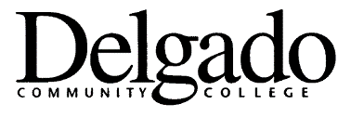
LIBERTY BANK SPONSORED
PROFESSIONAL DEVELOPMENT
BEST PRACTICES SERIES
GRANT APPLICATION (Maximum $250)
(Send two copies to Barry Brantley, Culinary Arts & Hospitality Department)

Applicant's Name: Campus/Unit:

Division/Area: Phone:

Please complete the following:

TITLE OF PRESENTATION:

A. Brief Abstract

B. Objectives of Session

C. Outline of Presentation

D. Logistics

When you like the workshop to be scheduled for (give as wide a range as possible)?

What day of the week and time do you prefer for the presentation (give multiple choices)?

What type of room do you need (classroom, conference room, lab, etc)?

What equipment will you need?

