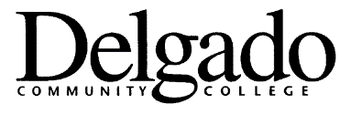
ORAL AND WRITTEN PROFICIENCY FORM

This is to certify that ___________________________________ (name of prospective faculty member) has demonstrated the oral and written proficiency required to conduct teaching activities at Delgado Community College.

____________________________ _________________
Division Date

_____________________________________
Signature of Division Dean

Form 2122/004 (4/22)

