Policy No. HR-4310.3A
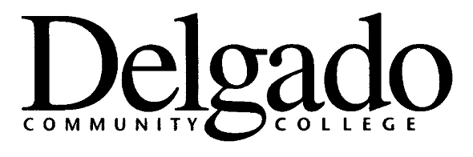

POLICY & PROCEDURES MEMORANDUM

TITLE: RESPONSIBLE
EMPLOYEE USE OF
ALCOHOL AT COLLEGE
FUNCTIONS

EFECTIVE DATE: June 21, 2005

CANCELLATION: none
OFFICE: Human Resources (HR)

POLICY STATEMENT

In accordance with Louisiana Community and Technical College Policy II.1.009, Alcohol Use In/On LCTCS System Facilities and Properties,” the consumption of alcohol on Delgado’s campuses/sites is not allowed except at official College-sponsored events. The use of alcoholic beverages is strictly prohibited without written permission of the Chancellor or his/her designee.

When alcoholic beverages are served at official College-sponsored events, responsible and legal consumption is expected. Alcoholic beverages served on campus at college functions are to be provided ONLY by the College, and, in accordance with Louisiana Revised Statute 14:93:12, no person under the age of 21 is to be served alcoholic beverages. The College reserves the right to refuse serving alcoholic beverages to or remove from the event any participant who will not furnish proof of age, whose behavior is disorderly, or who appears intoxicated.

As members of the College community, faculty and staff are expected to comply with and abide by this policy as well as local and state laws. Faculty and staff and their organizations who violate College policy or federal, state, or local laws regarding the use of alcohol will be subject to sanctions.

Faculty and staff have the special responsibility as members of a state institution of higher education to model mature and responsible behavior regarding alcohol use at on- and off-campus College-sponsored events. Alleged violations of this policy will result in review by the immediate supervisor and possible referral to the Director of Human Resources for disciplinary action in accordance with existing personnel policies and procedures.

SIGNATURE

Alex Johnson
Chancellor

Policy Reference:
Louisiana Community and Technical College Policy II.1.009, Alcohol Use in/On LCTCS System Facilities and Properties
Louisiana Revised Statute 14:93:12
Louisiana Revised Statute 14:93:13

Review Process:
Ad Hoc Committee on Responsible Alcohol Use at College Functions 4/21/05
Business and Administrative Affairs Council 5/24/05
College Council 6/21/05

Distribution:
Electronic Distribution Via Intranet and Email Systems

