Delgado Community College
CURRICULUM COMMITTEE
MINUTES
Friday, February 11, 2005 - 2:00 p.m.
City Park Campus - C.A.T.T. Conference Room (Building 10)
- Call to Order
Curriculum Committee Meeting was called to order at 2:05 p.m. by Harold Gaspard, Chairman.

- Roll Call
Present were: Lester Adelsberg Linda Kieffer Mary Bartholomew Estella Lain
Celyn Christophe Dehorah Lea
Maria Cisneros/Janet Stephens Mary Ellen Logan
Harolyn Cumlet Kathleen Mix/C.Christophe
Jill Dapremont Cheryl Myers
Greg Dawson Mike Nixon
Chris Doyle Sallye Raymond
Harold Gaspard Dolores Smith
Joan Hodge Dianne Thames Leroy Kendrick/C.Christophe Schountilez Williams
Absent/attending
to other business: Donna Alley Patrice Moore Wayne Chalona Deborah Taylor Morgan
Arnel Cosey Debra Redfearn
Patricia Egers Lauren Tarantino
Sheila Hickman Sonia Taylor

Guests were: Patrick Cote Wesley Payne
Chidi Onyenekwu Marvin Thames

- Minutes of Meeting – December 3, 2004
Minutes of the meeting of December 3, were moved for acceptance, as is.

- Debbie Lea’s Report
All items recommended at the last meeting were approved by the Vice Chancellor for Learning and Student Development except for:
General Education Course Addition
HUMA 175 Introduction to Film History
Add to Humanities General Education Requirement Listing
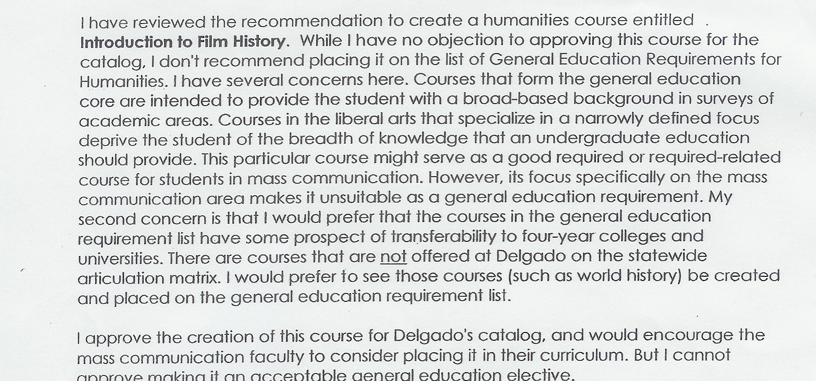
Dr. Smith’s response included the following:

Dr. Adelsberg expressed appreciation to Dr. Smith for setting the precedence of objecting ‘in writing’ to the committee’s recommendations and moved that the committee could look at future courses using this memorandum as a policy guide. [Debbie Lea/Mary Ellen Logan] Motion to accept proposal. Motion carried unanimously. The memorandum has been copied to all members.

In regard to updating the “Master Syllabi”, Debbie Lea had been receiving all current syllabi as well as requests for courses to be deleted. She will compile the requests to delete courses with a view to obtaining signatures from the relevant Deans, and then present to the Committee for authorization.

- New Business
- Business, Mathematics and Technology:
Change of number of contact hours:
Change the number of contact hours from 30 to 45 in MSTH Pathology for Massage Therapy
to meet the new eligibility requirement for taking the National Certification Examination for Therapeutic Massage and Bodywork (NCETMB). [Estella Lain/Mary Bartholomew] Motion to accept proposal. Motion carried unanimously.

2) Culinary Arts/Business and Technology:
New Program:
Program proposal for Certificate of Technical Studies in Culinary Management. [Greg Dawson/Estella Lain] Motion postponed until March meeting, pending amendments.

3) Business, Mathematics and Technology:
Certificate of Technical Studies – Homeland Security and Emergency Management.
- Thirteen (13) New Syllabi (see attachment)
- Course Description for the Catalog
- Program Description for the Catalog
iv. Curriculum
(Item withdrawn until February 25, pending amendments)

VI. Old Business
The TCA Transfer Requirement Sub-committee had met that day and Chairman, Debbie Lea, reported that recommendations on changes to the PPM Policy No. 1447.1C Academic Diplomas and Certificates of Completion, would be submitted to Karen Laiche on Tuesday, February 15 in time to possibly present to the Committee at the February 25, meeting.

VII. Adjournment 3:25 p.m.

VIII. Next Meeting February 25, 2005

