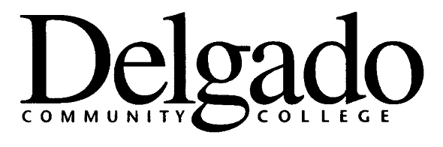
Technical College Credit

Students who have attended a campus of the Louisiana Technical College since January 1992 may apply for credits based on work completed at the LTC prior to their enrolling at Delgado Community College. Faculty at Delgado Community College have reviewed the competencies included in these clock-hour courses and have established a crosswalk for the awarding of these credits.

Specific procedures have been established for the granting of college credit from non-traditional sources:

- Students who were enrolled at Louisiana Technical College in 1992 or later will be awarded credit based on their coursework at the LTC using the crosswalk established by the faculty in the various disciplines.

- These credits are being awarded using the non-traditional credit procedures in place at the College.

- These credits will be listed on the student’s Delgado academic transcript as “Technical College Credit.”

- As with all non-traditional credit, all Technical College Credit will carry a grade of “P.” Specific grades are awarded only for courses transferred directly from another regionally accredited institution. Since the crosswalk for awarding credit from the LTC is based on competencies gained in more than one LTC course rather than on a course-to-course equivalency, it would be inappropriate to assign a letter grade for the credits awarded.

- Credits awarded are subject to the limitations on total hours of non-traditional credit and hours in a student’s major as listed in the College Catalog.

- Students who wish to avail themselves of this avenue for earning credits should complete the application form which is available in the Admissions Office.

- The form must be submitted to the Office of the Registrar for processing.

Note: Students who were enrolled at the LTC-NO on July 1, 1997, when the institution merged with Delgado Community College, will not be subject to the limits placed on the number of hours that can be earned and used to meet degree requirements through the non-traditional credit procedure.

- - - - - - - - - - - - - - - - - - - - - - - - - - - - - - - - - - - - - - - - - - - - - - - - - - - - - - - - - - - - - -
Policy Reference:
Original publication in Policy and Procedures Memorandum, DM 1440.2G, Academic Procedures Manual, issued August 15, 1994.

Updates Approved by Academic Affairs Council 2/15/07

