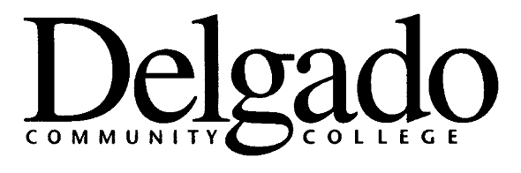
GENERAL STUDIES DEGREE PLAN

Students who choose to major in General Studies must file a degree plan with the Registrar’s Office. Students are notified during their first semester of enrollment of the necessity to meet with an advisor to complete such a degree plan.

The plan should be done on the Educational Degree Plan (Form 1505/001). Each degree plan must conform to the following requirements:

GENERAL STUDIES REQUIREMENTS

Once the Academic Counselor or General Studies Program Coordinator has met with the student and developed the degree plan, the student receives a copy of the plan and brings the original to the Registrar’s Office. Deviations from the plan must be approved by the Academic Counselor or General Studies Program Coordinator and the revised plan must be submitted to the Registrar’s Office.

1. A degree plan must be developed by the student and the Academic Counselor, or the General Studies Program Coordinator upon completion of 24 hrs and before the completion of the final 15 semester hours.

2. Degree plans must be filed within the first two weeks of the semester in order for the credits taken during this semester to be included in these 15 semester hours. Degree plans will not be prepared during registration.

3. The degree plan must be signed and dated, with the Academic Counselor/
General Studies Program Coordinator. The student maintains a copy, as well as the Academic Counselor. It is the student’s responsibility to ensure that a copy is
placed on file in the Registrar’s Office.

4. Students who later wish to make a change in their degree plan should see the
Academic Counselor or the General Studies Program Coordinator, or the
Associate Dean of Arts & Humanities Division to initiate a revised plan. All changes from the original degree plan on file must be approved through the appropriate administrative channels.

5. Effective Fall 1994, at least 9 of the 18 credits in the major (concentration)
must be completed at Delgado, and at least six (6) of these hours must be 200
level courses.

6. Effective Fall 1994, 25% of credits applied toward the degree must be completed
at Delgado Community College, 9 of the final 15 credits applied toward the degree must be taken at Delgado, they may not be non-traditional credit (CLEP, LEAP, credit exams, or military credits) or transfer credits.

7. Those students who seek to receive financial assistance or Veterans benefits
must declare a major and complete a degree plan before any entitlement can
be awarded.

- - - - - - - - - - - - - - - - - - - - - - - - - - - - - - - - - - - - - - - - - - - - - - - - - - - - - - - - - - - - - -
Policy Reference:
Original publication in Policy and Procedures Memorandum, DM 1440.2G, Academic Procedures Manual, issued August 15, 1994.

Updates Approved by Academic Affairs Council 2/15/07

